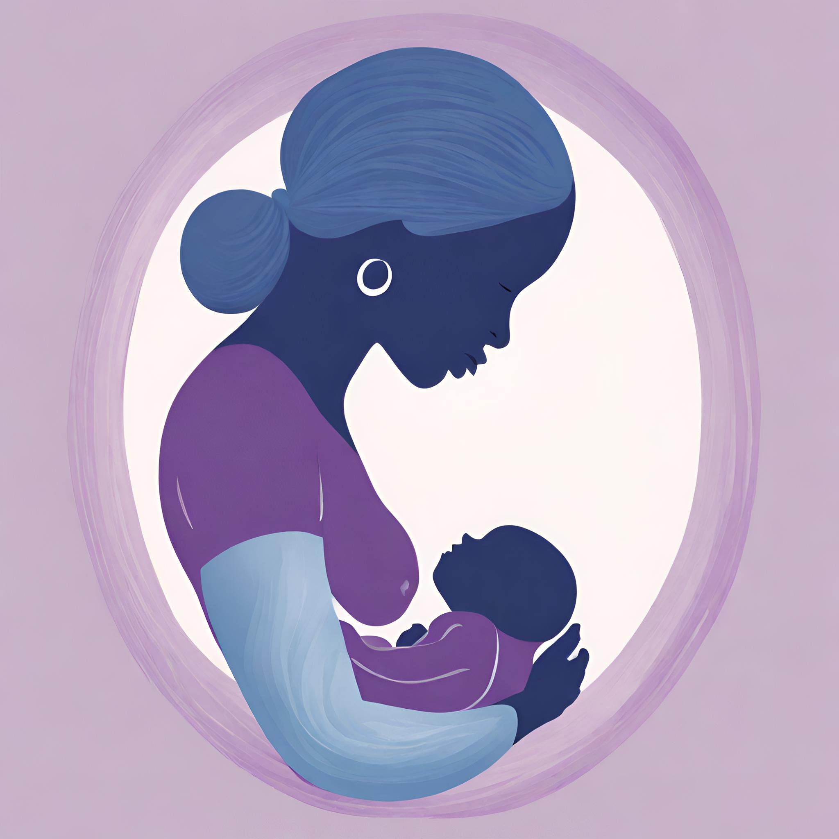

Redemptive Childbirth ^{sm}
Doula/Doulē Certification Curriculum

Developed by
A Grass Roots Perinatal Collaborative
The Nehemiah Birthing Project©

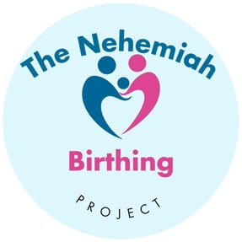

Sponsored by
A Grass Roots Perinatal Collaborative

Doula Training Certificate Program
Phase I Doula/Doulē Coursework

1. Course Title and Description:
This section clearly states the name of the course and provides a brief overview of its purpose and objectives.
Course Description:
This comprehensive Doula Training Program aims to provide women with the knowledge and skills necessary to support individuals and families during pregnancy, childbirth, and the postpartum period. The course covers various aspects of doula work, including emotional and physical support, advocacy, communication, and self-care. Participants will gain a deep understanding of the role of a doula and learn how to provide compassionate, evidence-based care to expectant parents from a holistic perspective. This course uniquely prepares Doulas to provide support for individuals and families in homes, birthing centers, or hospitals. Throughout this text you will see the word Doula/Doulē used interchangeably with the word doula. The inclusion of the original Greek word for Doula is Doulē and is used to emphasize the unique certification of our holistic doula program from other programs.

Our program supports the mission of The Nehemiah Birthing Project and adheres to its core values of education, support, safety, and faith.

Top of Form

Bottom of Form

2. Course Learning Objectives:
- This section outlines the specific knowledge and skills that students will gain from the course.
Course Objectives:
- Identify the various worldviews of childbirth and the cultural differences affecting Doula/Doulē care.
- Identify the role and responsibilities of a doula in the various birthing environments.
- Develop effective communication and active listening skills.
- Provide emotional and physical support to individuals and families during pregnancy, childbirth, and the postpartum period.
- Advocate for the rights and choices of expectant parents
- Promote evidence-based practices and informed decision-making.
- Recognize and respond to common physical, emotional, and spiritual challenges during pregnancy and childbirth.
- Develop a comprehensive understanding of the stages of labor and strategies for comfort and pain relief.
- Gain knowledge about breastfeeding, infant care, and postpartum support
- Develop self-care personal practices to prevent burnout and maintain personal well-being.
- Establish professional boundaries and ethical guidelines for doula work.
- Follow sound business practices for Doula/Doulē services that depict our core values of education, support, safety and faith.

3. Course Modules

WEEK 1 1. Worldview and Cultural Considerations of Childbirth
WEEK 1 2. Doula/Doulē Service and work
WEEK 2 3. Communication and Active Listening Skills
WEEK 3 4. Emotional Support During Pregnancy and Birth
WEEK 4,5 5. Physical Support During Pregnancy and Birth
WEEK 6 6. Advocacy and Informed Decision-Making
WEEK 7,8,9 7. Anatomy & Physiology of Labor and Birth
WEEK 10,11 8. Postpartum Support and Infant Care
WEEK 12 9. Self-Care, Professional Development, & Boundaries
WEEK 12 10. Business Practices for Doulas/Doulēs

4. Course Modules: Completion Timeline
This section provides an overview of the topics and modules that will be covered in the course, along with a brief description of each.

Module 1: Worldview and Cultural Considerations of Childbirth
- The impact of culture on childbirth

- Cultural beliefs and practices
- Providing culturally sensitive doula care
Module 2: Doula/Doulē Service and work
- Worldview of Childbirth
- The Doula/Doulē, among healthcare providers
- History and types of Doula training and care
- Role and responsibilities of a doula
- History and philosophy of Doula support
- Scope of practice and professional standards

Module 3: Communication and Active Listening Skills
- Faith and effective communication techniques
- Active listening and empathy
- Building rapport and trust with clients
- Building rapport and trust with the birth staff and family
- Interdisciplinary teamwork & professional boundaries with providers.

Module 4: Emotional Support During Pregnancy and Birth
- Understanding emotional needs and fears of expectant parents
- Providing non-judgmental and compassionate support
- Techniques for adequate emotional support

Module 5: Physical Support During Pregnancy and Birth
- Comfort measures and pain relief techniques
- Positioning and movement during labor
- Massage, breathing, and relaxation techniques
- Aromatherapy & Hydrotherapy

Module 6: Advocacy and Informed Decision-Making
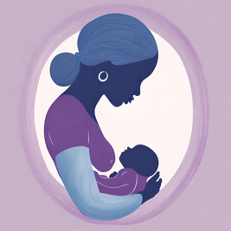
- Supporting informed choices and autonomy
- Strategies for effective advocacy
- Understanding medical interventions and their alternatives
- Medicaid-specific patient rights & hospital navigation scenarios.
- Pain management options

Module 7: Pregnancy, Labor, and Birth
- The Anatomy & Physiology of the Reproductive system
- Hormones of Labor
- Stages of Pregnancy & Assessments
- Stages of Labor and the Physiologic Birth Process
- Physical, Emotional, Spiritual Support Techniques for each stage.
- Partner support and involvement
  - Childbirth Education
- The role of a birth father/partner
- Supporting birth father/partners
- Communicating with birth father/partners
- Common challenges and watchfulness

Module 8: Postpartum Support and Infant Care
- Postpartum doula support
- Supporting the transition to parenthood
- Common post-partum complications, challenges, and watchfulness
- Breastfeeding assistance, troubleshooting, and the Lactation Consultant
- Newborn care, safety, and soothing techniques

Module 9: Self-Care, Professional Development, and Boundaries –
- Importance of self-care for doulas
- Preventing burnout and managing stress
- Continuing education opportunities
- Establishing professional boundaries and ethics
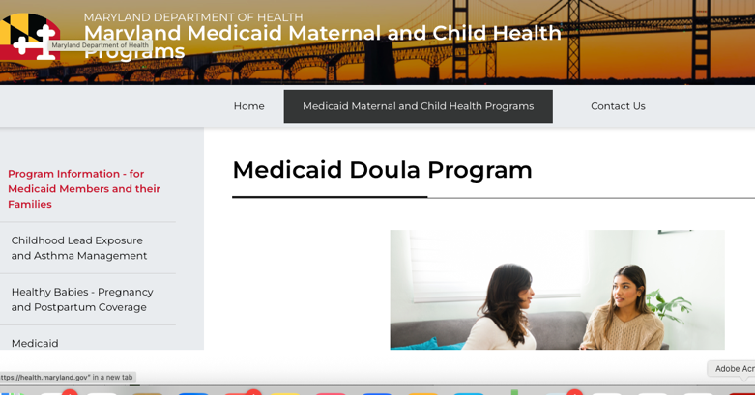
- Emergency Awareness and Referral

Module 10: Business Practices for Doulas
-Setting fees
-Marketing and advertising
-Networking
-Professional liability insurance
Becoming Medicaid-qualified provider

14. Faculty &Staff
Our highly qualified professional planning committee, content presenters and The Nehemiah Birthing Project board members are listed below and ready to serve you.

Faculty & Staff and Board Members

Forrest T. Closson, MD
Baltimore Magazine Top Doctor
Laurel, MD

Malika Closson, MD
Double Board-Certified Adult and Child & Adolescent Psychiatrist
CEO/Owner, Closson Psychiatric Consultants, LLC

Marcella A. Copes, Ph.D., RN
President & CEO at MTB health Care
Consulting LLC
Bowie, MD

Cora Caver JD
Legal Advisor GO! Education
Board member, The Nehemiah Birthing Project
Little Rock, AR

Danielle Edmonson, MA
Project Manager
Board member, The Nehemiah Birthing Project
Silver Spring, MD

Donna J. Ezell, RN
Executive Director
Caring Hearts Pregnancy Center
Little Rock, AR

Gwenerviere Hester, MEd, BSN, RN
Alternative Methods Consultant
Board Member The Nehemiah Birthing Project
Durham, NC

Glesi Lambert, MSN, RNC-OB, C-EFM
Clinical Instructor University of Maryland
L&D Clinical Nurse Shady Grove Medical Center
Silver Spring, MD

Brian D. Lee
CEO Label Me Other
Instructional Designer eLearning Developer
Scorm/LMS
Little Rock, AR

Sharon Moore, PhDTh, MEd
Pastor Of Outreach Fellowship Christian Center
Little Rock School District Special Education Teacher
Board member, The Nehemiah Birthing Project

Charice Riggins, MSN, RNC-OB
Clinical Nurse L&D Baptist Medical Center
Little Rock, AR

Cynthia Smith, MS, CD (Mama Toto)
Mama TOTO Village Doula
Certified Doula Medicaid Provider
Washington D.C.

Melony Stokes, DNP, RNC-OB
Institute of Digital Health and Innovation (IDHI)
Senior Program Director of South-Central Telehealth Resource Center
University of Arkansas for Medical Sciences (UAMS)
Little Rock, AR

Rita Tuggle
Instructional Designer eLearning Developer
Scorm/LMS
Little Rock, AR

Cheryl J Washington EdD, MEd, BSN, RNC-OB, C-EFM, CD (ProDoula), SpBWP
CEO GO! Educational Services, LLC
President The Nehemiah Birthing Project
Visionary Redemptive Doula Certification Program
Laurel, MD

Erica Nix, RNC-OC CD, IBCLC,
Lactation Consultant UAMS
Doula
AWHONN Fetal Monitoring Instructor

Doula Certification Content Contributors
- Marcella A. Copes, Ph.D., RN
- Donna Ezell, RN
- Gwenerviere Hester, MEd, BSN, RN
- Glesi Lambert, MSN, RNC-OB, C-EFM
- Charice Riggins, MSN, RNC-OB
- Cynthia Smith, CD (MamaToto)
- Melony Stokes, DNP, RNC-OB
- Cheryl J Washington EdD, MEd, BSN, RNC-OB, C-EFM, CD
  - (ProDoula), SpBWP 10/30/2025)
Continuing Professional Education Planning Committee
- Forrest T. Closson, MD
- Malika Closson, PhD
- Marcella A. Copes, Ph.D., RN
- Donna Ezell, RN
- Cynthia Smith, CD (MamaToto)
- Melony Stokes, DNP, RNC-OB
- Cheryl J Washington EdD, MEd, BSN, RNC-OB, C-EFM, CD (ProDoula), SpBWP
Board of Directors TNBP
- Cora Caver, JD
- Danielle Edmonson, MA
- Gwenerviere Hester, MEd, BSN, RN
- Sharon Moore, PhD (candidate) MEd
Cheryl J Washington, EdD, MEd, BSN, RNC-OB, C-EFM, CD (ProDoula), SpBWP

